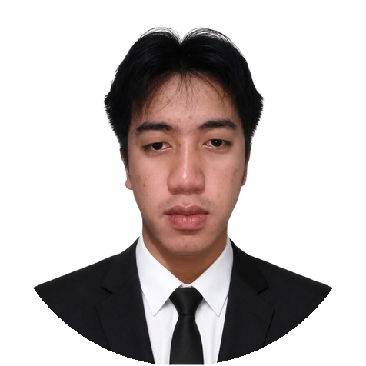 | Jade Xaviery J. Felicidario   Jadefelicidariojava@gmail.com  0935 257 8535  Buhisan, Cebu City, Philippines 6000
Professional Summary
Aspiring UI/UX and front-end professional who turns ideas into simple, intuitive designs using Figma, HTML, and CSS. I stay composed under pressure and communicate in a friendly, clear way, whether I’m working with teammates or clients. I’m motivated to keep improving my skills and to take part in work that makes a real difference.
Work Experience
Work Immersion – University of Cebu Main Campus 2023-04-05 – 2023-05-03 | Sanciangko St. Cebu City
Maintained the organization and completeness of the computer laboratory tools to ensure they were always ready for use.
- Assisted the teacher during students’ hands-on activities by guiding them in assembling and disassembling computer system units.
- Served as the person in charge of tool storage, handing out equipment to students and checking that every item was returned.
- Helped the teacher check students’ LAN cable wiring, verifying whether connections were straight-through or crossover.
- Contributed to a safe and orderly laboratory environment by following procedures and keeping the work area tidy.
- Prepared workstations and equipment before sessions so students could begin their activities on time.
- Kept the computer laboratory clean and orderly by regularly tidying workstations and common areas to ensure a pleasant learning environment.

Education
Bachelor of Science in Information Technology
Cebu Eastern College, Incorporated – Leon Kilat St, Cebu City 2023 – 2026 Undergraduate
General Academic Strand
Punta Princesa National High School Night – Punta Princesa, Cebu City 2021 - 2023 — Graduated

Skills
Front-end Developer: HTML, CSS, Responsive Web Design, User Interface Testing, Web Page Layout
UI/UX Design: Figma, Wireframing, Prototyping, User-Centered Design
Soft Skills: Attention to Detail, Time Management, Team Collaboration, Communication
Multimedia: Photo Editing, Basic Video Editing

